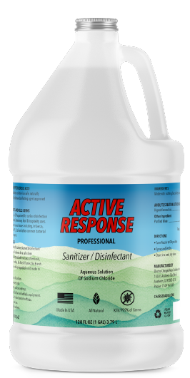

ECAS Logo  
Electrocharged Aqua Solutions



**EPA N List Approved Medical Grade Hypochlorous Acid**

**Kills 99.99% of viruses, bacteria and other microbes, including COVID-19**

**FAQ’s**

**We are the manufacturer with the world’s best devices to make the most consistent, effective and stable hypochlorous acid solutions.   
Want to make your own? click here**

Our Story  
[pic of our founder]

“Hypochlorous acid saved my life…”   
- Erv Tallman, Founder ECAS